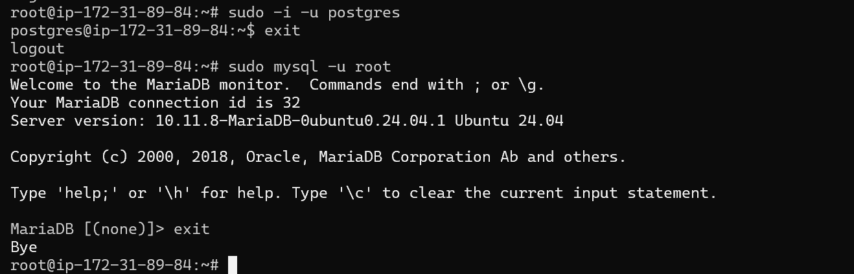  
  
Both mariadb and Postgres are installed

Mariadb

CREATE TABLE employees (

id INT AUTO_INCREMENT PRIMARY KEY,

name VARCHAR(255) NOT NULL,

position VARCHAR(255),

salary INT

);

Postgresql

CREATE TABLE employees (

id SERIAL PRIMARY KEY,

name VARCHAR NOT NULL,

position VARCHAR,

salary INTEGER

);